How we teach our children at Sandiway Primary School

Curriculum Planning
- Small steps and sequencing
We break larger concepts into small steps to ensure that children’s working memory is not overburdened.
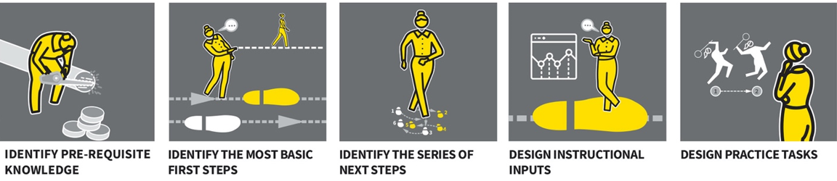
Explaining and Modelling
- Big picture, small picture
We use big picture, small picture to provide a context for learning and to help organise children’s schema.
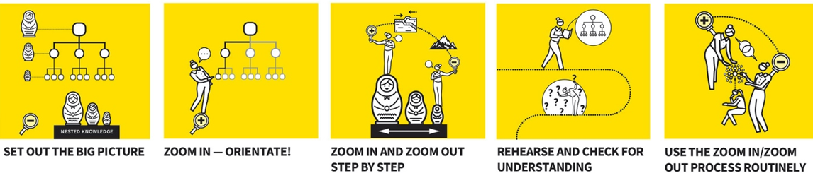
- Live modelling
We use live modelling so that children have a clear understanding of what they are required to do.
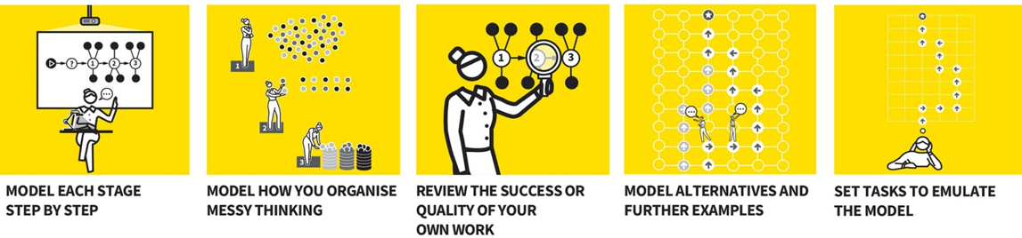
- Metacognitive talk
We use metacognitive talk to make the implicit, explicit and reveal the thinking behind complex processes.
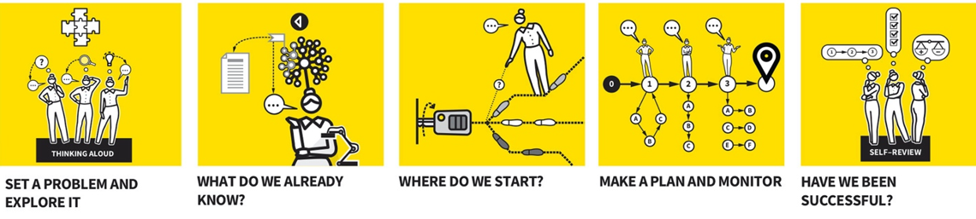
Questioning and Feedback
- Cold calling
We use cold calling to ensure children are habitually thinking about the questions the teacher has posed.
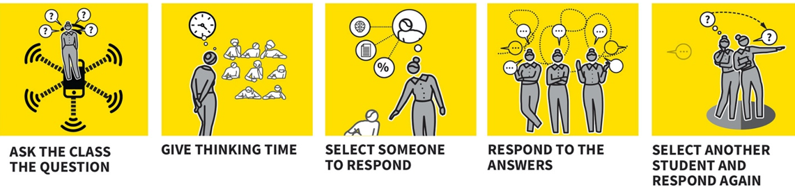

- Think, pair, share
We use think, pair, share to provide opportunities for children recall, rehearse and share ideas at regular intervals.
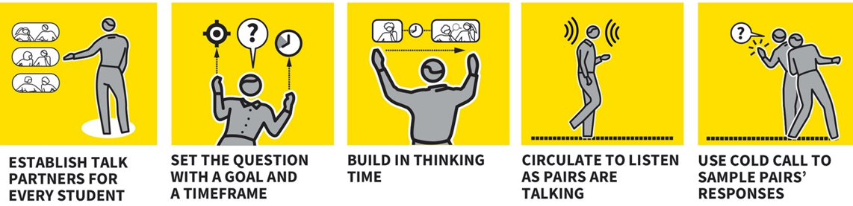
- Check for understanding
We use check for understanding to regularly gauge what children have understood and identify where misconceptions have occurred.
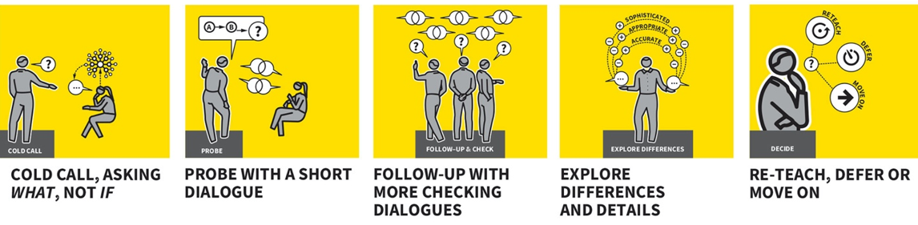
Behaviour and Relationships
- Signal, pause, insist
We use signal, pause, insist to create clear routines and ensure children respond promptly when teachers require their attention.
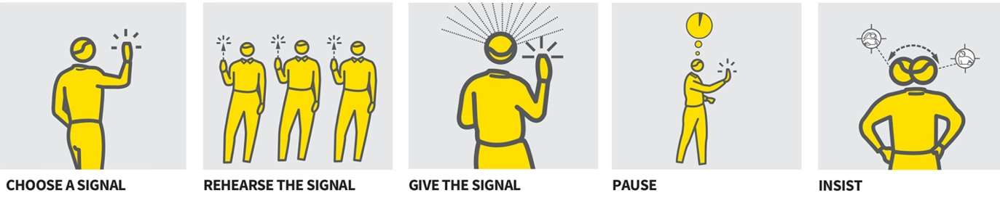
- Positive relationships
We create positive relationships to ensure that we model kindness whilst developing a professional, effective relationship.

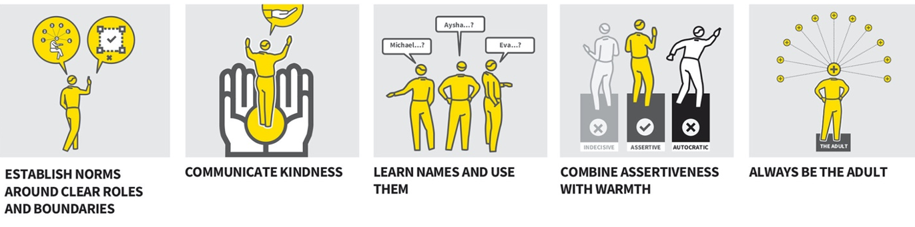

Retrieval and Practice
- Quizzing
We use low-stakes quizzes to ensure children retain previously taught concepts.
