Sandiway Primary School
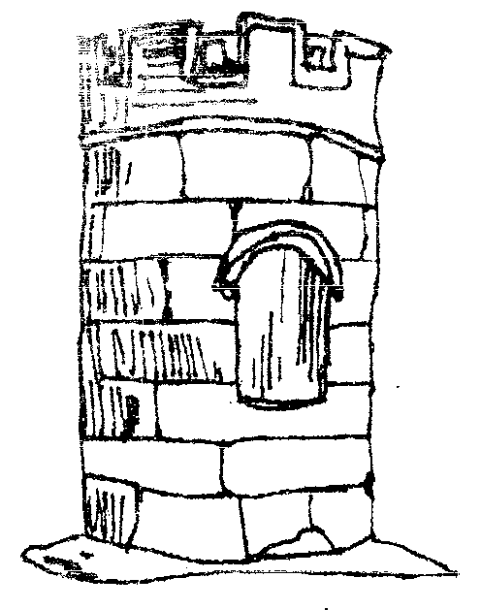
Code of Conduct
Home School Agreement
Breakfast Club and Club ROCK
(before and after school club)
It is a statutory requirement under sections 110-111 of the School Standards and Framework Act 1998 for all maintained schools, academies, and city technology colleges to adopt a Home-School Partnership Agreement.

Growing and Achieving Together
At Sandiway Primary School we are committed to high expectations in all areas of school life. We believe that the needs of each individual child are best served when school and home work together in close partnership.

Name:__________________________Date:_____________

Club | Parent | Child
As a before and after- school club we will:  - provide the highest quality of childcare, treating your child with respect and value.  - consistently have high expectations of children’s behaviour, adhering to the schools ROCK Values (Respect, ownership, care and kindness).  - provide a safe and nurturing environment where safeguarding is a priority.  - provide a variety opportunities for children to engage in.  - be open and welcoming.  - provide information about the child’s experience in club.  - treat all children and parents fairly, professionally and without discrimination.  - work with parents/carers as partners.  - not tolerate staff being treated inappropriately by children, parents or carers.  - engage with parents/carers regarding any problems or concerns in a respectful manner.  - where behaviour is a concern, deal with poor behaviour in line with the school behaviour policy  - address persistently challenging behaviour with individual support plans. If these can not be adhered to, persistent challenging behaviour may result in the termination of the club place. | As parents and carers we will:  - support the work undertaken by the school, including the behaviour policy.  - share information (ensuring emergency contacts are always updated and we are informed of changes to medical conditions, allergies and intolerances).  - ensure school is informed of any changes to existing arrangements made with club as soon as possible.  - aim to be punctual (late pick ups will incur an additional payment)  - ensure adults collecting from the provision are known to school (if you wish other family members etc to collect children, please ensure introductions are done in advance- if in doubt school will make contact with parents to establish who is taking their children).  - uphold the schools ROCK values when dealing with staff.  - discuss any concerns with staff in an appropriate, respectful and discrete manner.  - support club to address persistently challenging behaviours that may be being presented by your child. | I will:  - Uphold the school values of Respect, Ownership, Care and Kindness (ROCK) at all times.  - Have high expectations of my own behaviour  - work hard to be the best I can be.  - be polite, friendly and helpful to others.  - respect school and other people’s property.  - be honest and truthful.  - be gentle (We don’t hurt others).  - listen carefully.  - work well with others.  - ask for help when I need it.  - tell someone if I am unhappy.  - Work with staff to make my time in club enjoyable  - Be a positive role model to other children.
Signed: ………………………………………………………... | Signed: ………………………………………………………. | Signed: ……………………………………………………….

