7

Schools must use the funding to make additional and sustainable improvements to the quality of PE and sport they offer. This means that schools should use the Primary PE and Sport Premium to:

- develop or add to the PE and sport activities that your school already offers
- 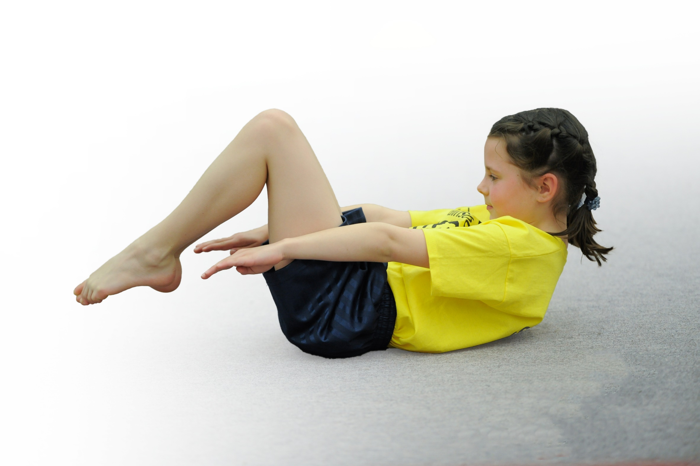build capacity and capability within the school to ensure that improvements made now will benefit pupils joining the school in future years

Please visit gov.uk for the revised DfE guidance including the 5 key indicators across which schools should demonstrate an improvement. This document will help you to review your provision and to report your spend. DfE encourages schools to use this template as an effective way of meeting the reporting requirements of the Primary PE and Sport Premium.

We have reflected on the impact of current provision and have reviewed the previous spend.
Under the Ofsted Schools Inspection Framework, inspectors will assess how effectively leaders use
the Primary PE and Sport Premium and measure its impact on outcomes for pupils, and how effectively governors hold them to account
for this.

Schools are required to publish details of how they spend this funding as well as on the impact it has on pupils’ PE
and sport participation and attainment.

Support for review and reflection - considering the 5 key indicators from DfE, what development needs are a priority for your setting and your students now and why? Use the space below to reflect on previous spend, identify current need and priorities for the future.

Key achievements to date: | Areas for further improvement and baseline evidence of need:
Outdoor adventurous taster activities through ‘Get Outside the Classroom’ delivered across whole school.  Won 9/14 local level sports competitions, finished 1st – 3rd in 6 Vale Royal level competitions and runners up in 1 Cheshire competition, 1 more to be run.  100% of Year 5 and 6 and 73% of whole of KS2 competed in inter-school competitions. | Engage identified less active (20% of all children – through questionnaire and participation spreadsheet) in more physical activity.  Improve number of sports involved in intra-school competition (from current of 5 to aim of 7 to ensure gold standards are met next year.)  Establish throughout the school ‘active lessons’ using ‘Quick lesson breaks’ document as a starter. Heat maps will show an improvement across the school.

Meeting national curriculum requirements for swimming and water safety
What percentage of your current Year 6 cohort swim competently, confidently and proficiently over a distance of at least 25 metres? | 75%
What percentage of your current Year 6 cohort use a range of strokes effectively [for example, front crawl, backstroke and breaststroke]? | Unknown due to being assessed 2 years ago before requirement existed.
What percentage of your current Year 6 cohort perform safe self-rescue in different water-based situations? | Unknown due to being assessed 2 years ago before requirement existed.
Schools can choose to use the Primary PE and Sport Premium to provide additional provision for swimming but this must be for activity over and above the national curriculum requirements. Have you used it in this way? | No

Action Plan and Budget Tracking
Capture your intended annual spend against the 5 key indicators. Clarify the success criteria and evidence of impact that you intend to measure to evaluate for students today and for the future.

Academic Year: 2017/18 | Total fund allocated: £ | Date Updated: July 2018
Key indicator 1: The engagement of all pupils in regular physical activity – Chief Medical Officer guidelines recommend that primary school children undertake at least 30 minutes of physical activity a day in school |  |  |  | Percentage of total allocation:
 |  |  |  | 36%
School focus with clarity on intended impact on pupils: | Actions to achieve: | Funding allocated: | Evidence and impact: | Sustainability and suggested next steps:
Membership of Vale Royal School Sports Partnership to ensure a range of sports competitions are organised along with training opportunities.  PE teacher working with groups of pupils during lunchtime to encourage leadership and increased physical activity.  Phys Kids programme to improve leadership skills amongst year 6 and participation of KS1 children. | Complete application form  Appoint champion. Identify children to lead and support activities.  Paul Finney (Weaverham High School) to train and PE leads to support 32 Year 6 children in delivering high quality and safe PE sessions to KS1 | £3300  £1404  £from VRSSP (see above) | Competed in 14 different sport competitions across the year. 100% of Year 5 and 6 and 73% of KS2 participated in those competitions.  Over 50% of Year 5 pupils involved in organising and leading activities. Increase in numbers of children physically active at lunchtime.  100% of Year 6 pupils involved organising and delivering sessions with KS1 children throughout year. | To continue as members of the partnership next year. Including signing up for ‘5 a day’ and ‘my personal best’ aspects.  To continue next year, but targeting identified group of least active children (20%) to be involved more.  To continue next year with new Year 5 cohort.

Key indicator 2: The profile of PE and sport being raised across the school as a tool for whole school improvement |  |  |  | Percentage of total allocation:
 |  |  |  | 0%
School focus with clarity on intended impact on pupils: | Actions to achieve: | Funding allocated: | Evidence and impact: | Sustainability and suggested next steps:
Celebration assembly to celebrate sporting achievements to inspire and encourage all pupils to take part in sporting activities.  Noticeboards to promote achievements and links to other clubs.  Assemblies to involve new sports/athletes to promote a range of sports and the impact of sport. | Sharing of achievements through certificates, reporting of competitions, awards.  Subject leads to update regularly and signpost parents to them.  Identify opportunities for new sports and athletes and invite to assemblies. | £0  £0  £0 | Pupils awarded certificates. Competition and especially success celebrated in front of whole school inspiring others to compete.  Noticeboards have some evidence of sporting competitions and leaflets promoting events and clubs.  Judo club demonstration at start of year led to 20 children taking part in a pre-school club. Jenna Downing, world champion inline skater attended assembly and gave an inspiring talk – especially focused on girls. (Y5 child asking excellent questions) | Continued celebration of achievements and competition. More evidence required for noticeboards.  To continue – see above link to assemblies.  Judo to continue next year.

Key indicator 3: Increased confidence, knowledge and skills of all staff in teaching PE and sport |  |  |  | Percentage of total allocation:
 |  |  |  | 12%
School focus with clarity on intended  impact on pupils: | Actions to achieve: | Funding  allocated: | Evidence and impact: | Sustainability and suggested  next steps:
Tennis coach to teach all year groups (1-6). Teachers observing to gain skills and knowledge.  Cricket coach to teach Y5-6, Y1-2. Teachers observing to gain skills and knowledge.  High school teacher to co-deliver with 4 year groups. Teachers to work alongside to gain skills and knowledge.  NQT to monitor PE lessons by experienced staff.  Cheshire Cricket Board girls’ cricket coach to run girls’ cricket after-school club (KS2) to inspire/increase numbers of girls participating. | Speak to Sandiway and Cuddington Tennis Club to organise timetable across year groups.  Arrange timetable with Cheshire Cricket Board contact.  Arrange timetable with Weaverham High School contact.  To be arranged by NQT.  Subject leader to arrange dates. | £1500  £free through Chance to Shine programme  Paid for through VRSSP (see above)  £0  £free through Chance to Shine programme | Through staff questionnaires, improvement in staff confidence and competence in delivering that sport has improved.  Through staff questionnaires, improvement in staff confidence and competence in delivering that sport has improved.  Through staff questionnaires, improvement in staff confidence and competence in delivering that sport has improved.  14 girls attended 5 weeks of delivery. | To continue next year - rotate and allocate according to teachers/class requirements.  To continue next year - rotate and allocate according to teachers/class requirements.  To continue next year - rotate and allocate according to teachers/class requirements.  Identify girls for possible girl’s club for next year.

Key indicator 4: Broader experience of a range of sports and activities offered to all pupils |  |  |  | Percentage of total allocation:
 |  |  |  | 36%
School focus with clarity on intended  impact on pupils: | Actions to achieve: | Funding  allocated: | Evidence and impact: | Sustainability and suggested  next steps:
Additional achievements:  Judo assembly and club to engage interest and improve sporting activity of less active children.  Well-being afternoons through the year across the whole school involving a range of sports, including yoga to improve mental health and well-being.  Outdoor activities taster to improve staff experience and confidence in developing and leading further next year.  Purchase new equipment to ensure that a range of activities continue to be offered.  Dance opportunity to be provided for Reception to engage and provide high quality teaching.  Street Dance teacher to be booked for next year to provide an opportunity for an after school street dance club. | Organise assembly and arrange dates for club.  Yoga teacher to be arranged to come in and deliver to children.  Organise action plan with ‘Get Outside the Classroom’.  Audit what equipment is required to ensure continuity of a range of sports offered.  Dance teacher to be organised by reception teacher.  Street Dance teacher to be booked for after school club for new term. | £0  £200  £2600  £1441  £100  £300 | 20 plus children attended the pre-school club. New local club arranged after school in area by Judo club.  Anecdotal evidence on display of enjoyment and engagement.  Staff engagement and enthusiasm improved.  Gym mats condemned have been replaced to allow gymnastics, dance and other indoor activities to take place. Cricket and tennis balls purchased for those sports and catching activities. Football posts and security equipment purchased to replace previous equipment to allow flexibility of use.  High quality dance taught to Reception. Children engaged and staff observed to improve awareness of skills.  Extra after school club organised for new term to engage extra range of children. | To continue next year.  To continue and develop further through whole staff training on child-friendly yoga and mats to be purchased.  Action plan is in place for next 3 terms and Y6 kayaking trip organised. Teachers to input to ‘Get Outside the Classroom’ on ideas for their class sessions.  Current equipment will continue to be audited.  Further opportunities sought to engage all classes to receive high quality teaching.  Book again for the following year.

Key indicator 5: Increased participation in competitive sport |  |  |  | Percentage of total allocation:
 |  |  |  | 16%
School focus with clarity on intended  impact on pupils: | Actions to achieve: | Funding  allocated: | Evidence and impact: | Sustainability and suggested  next steps:
Select teams for a range of sports – identifying further opportunities for B and/or C teams and less competitive events. Ensuring as many KS2 children as possible get opportunities to compete in inter-school events.  Questionnaire to identify less active children to develop ideas for future areas of development sports wise. To improve further the engagement of these children.  Providing opportunities for more able and least active through holiday academies. | Subject leaders to organise and track pupil participation. To arrange competitive sports through VRSSP and other opportunities as required. Travel to/from events to be funded to ensure attendance.  Subject leaders to pass to class teachers and analyse data for next year.  Identify 4 talented athletes and 4 least active athletes and invite to the academies. | £through VRSSP cost + travel (£1684)  £subject leader time  £400 | 100% Y5/6 and 73% KS2 children have been involved in inter-school competitions. 15 different events have been attended, with wins in 9 of those sports at the local levels. 2 wins, 1 runner up and 3 thirds at a Vale Royal level. One 2nd at a Cheshire level.  38 children identified from questionnaire/tracking spreadsheet passed to teachers and lunchtime champion.  4 children attended talented academy. 4 children attended encouragement academy. All enjoyed their programme. | To continue monitoring and involvement in sports across KS2.  Least active children to be identified from analysis. Lunchtime champion to focus on these children in pre-school and lunchtime clubs.  Monitor the least active children for improved activity. Redo if offered next year.

