Year Two Home Based Learning
Week 3- Monday 6th April 2020
We have reached the Easter Holidays and traditionally we do not set work during holidays, however we are in very different times so you may want some ideas to keep you busy.

The Padlet is proving popular and Mrs Whitney and I love looking at all the different things you are getting up to. Please keep posting. So far about 20 children from Year 2 are posting comments and photos on a regular basis. It would be great if we could get everyone in the class to join in. I am also uploading videos, comments and activities that might be useful.
If you haven’t already come and join us! https://padlet.com/satkinson16/gbfjjhomepv0

Zoom Meeting!
I would like to organise another zoom meeting with you at 2pm on Thursday. I will set the meeting up and send the link out to all parents via Mr Priddey.

If you want to contact me I will be checking my emails satkinson@sandiway.cheshire.sch.uk and I will do my best to respond promptly.
Reading | Read daily. This is probably the most important thing you can do.  Can you complete a reading challenge (see website)? It is great to see you have been accessing Bug Club, apologies if you ran out of books, I have updated this and will keep a closer eye on it. Glad to see your reading so much!  We now have access to Collins e-books and I have included the login info below. It is not as comprehensive as Bug Club but does give you a different selection of books. https://connect.collins.co.uk/school/portal.aspx  Click on Student sign in:  Class Name: Big Cat  Pupil First Name: Pupil  Pupil Last Name: Access  DOB: 01/01/2001  Year Group: 1  Everyone has the same login details so login, choose the colour band you are reading in class/Bug Club and select your book. There is a read aloud feature, to turn this off just press the pause button.
Writing | If you started a diary last week you could continue with this. I have also uploaded a Time Capsule activity book; you could use this or use it for ideas to create your own special Time Capsule.  Remember this is a time that in the future will be regarded as history.
Music | BASH THE TRASH!  Hi Everyone!  Here is a fun activity that you can do with your whole family. It’s going to be quite noisy at times so maybe do it in the garden if you can.  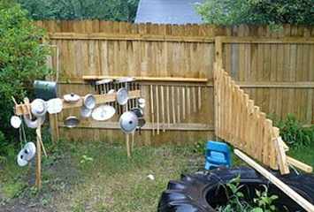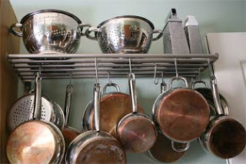  I’d like you to have a go at making your own instrument from recycled items. They don’t have to look like an instrument that already exists, just as long as they make an interesting sound.  When you’re happy with your piece, begin to create an ostinato (a repeated rhythmic pattern). Remember every instrument needs to have a different rhythm pattern that fits together so they must all equal the same amount of beats in total.  Take a look at couple of the websites listed below and watch some videos on Youtube, they’ll definitely inspire you!  https://www.bashthetrash.com/strings https://www.youtube.com/watch?v=7sUNXA4NYK  Watch this band, I’ve seen them live. They are amazing!  https://www.youtube.com/results?search_query=STOMP  When you’ve had a practise, record it and send me a copy or even just a photograph. I’d love to see it!  When we get back to school, we can all bring our instruments in and play together.  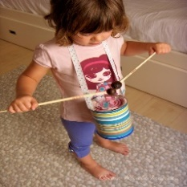  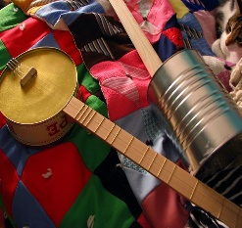  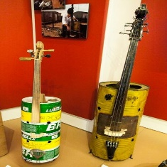  Have fun making a Junk Band and if the neighbours don’t like the noise, get them to join in!  Take care and I look forward to seeing you all soon.  From Mrs Tucker  stucker@sandiway.cheshire.sch.uk
Maths | I have attached a lovely Easter themed activity booklet on to the resources section of the website. This includes a range of activities we have completed over the year.  Please pick and mix activities that you would like to work on. It might be that you pick one or two activities per day. Some of you eager mathematicians might want to complete more but it is not an expectation to do all of it.
Other suggestions | The following website has loads of nice ideas for Easter based practical activities  https://www.teachingideas.co.uk/dt/20-egg-citing-easter-challenges-for-children  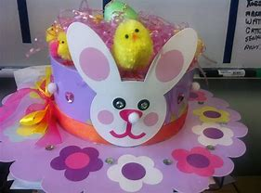
PE/exercise | The Body Coach  Remember, the body coach is on each day at 9am  Cosmic Yoga  Available on YouTube or you can download the free app.  Just Dance  https://www.youtube.com/justdance

