Year Three home based work
For the week beginning 4th May 2020
Please don’t feel like you have to do all of these, they are just suggestions.
I know it would have been the Easter holidays now but because you are all safely staying at home we thought we would still give you suggestions for activities to do to try to keep you busy.

deputy@sandiway.cheshire.sch.uk or khandley@sandiway.cheshire.sch.uk

Don’t forget to upload anything you are keen to share on our Padlet board. We may even add a few spontaneous challenges to our Padlet board too

Reading | Read at least three times and if possible daily. Paper books, Bug club and library books.  Most importantly, enjoy your reading. Choose texts that excite you.  Continue with any book recommendations on Padlet.  This week I have attached two comprehensions to have a go at. One is about survival in Ancient Egypt and the other is about King Tutankhamun. In these comprehensions, there are three star sheets which contain the most challenging questions, two stars are suitable for the majority of children and if the two star questions are two tricky, there are one star questions to try instead.
Writing | As last week, there are a number of Egyptian themed writing opportunities listed in the Topic work section below.  Some speaking and listening activities that may be interesting:  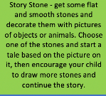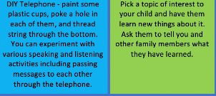  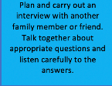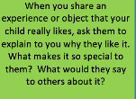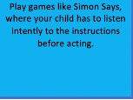  Grammar and Punctuation Activity:  This week I have attached a sheet to review and extend your knowledge of prepositions. Try to use this sheet as a way to also practise your joined handwriting and consider your presentation.  I will leave this up as an ongoing activity for you to keep having a look at:  Go back and review spellings covered since September and ensure you are still confident in spelling these words.  Additionally, return to the Y1 and 2 spelling list (a copy is on the Y3 page of the school website) and be really confident to spell these words accurately.
Maths | Please continue with the addition and subtraction workbook and the multiplication and division workbooks that I have attached over the last couple of weeks.  This week I have uploaded a series of worksheets that support your learning of geometry in Y3. You will have come across the majority of the terminology you need before in Y2.  - You will also need to understand what a parallel line is and what a perpendicular line is. Parallel lines are lines in a plane which do not meet. A line is perpendicular to another if it meets or crosses it at right angles (90°).  - You will need to review what a right angle is (90°). An angle larger than a right angle is called an obtuse angle and an angle smaller than a right angle is an acute angle. Try identifying right angles, obtuse angles and acute angles around your house.  A few more maths ideas to keep you busy this week:  You will need a pack of playing cards for these  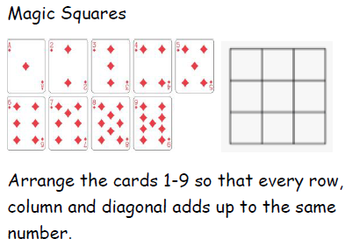  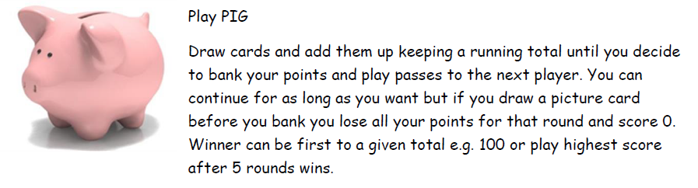  Draw a place value grid like the one shown.  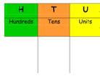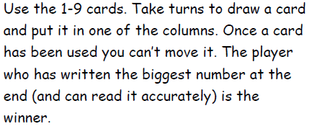  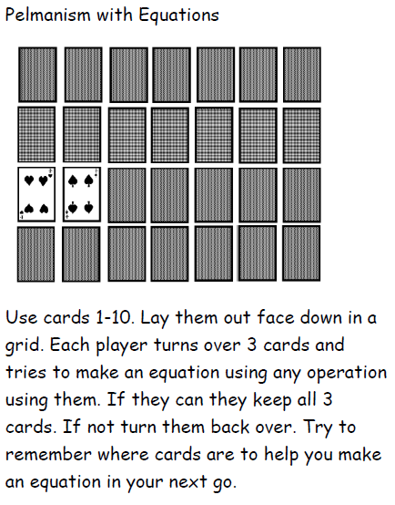  (Thanks to First4 maths for these ideas)  As always, keep up with times tables practise if you can.
Topic/ Creative work | Ancient Egyptians.  What was life like for an Ancient Egyptian?  What sort of jobs did Egyptian people have?  What sort of food did they eat?  What sort of drinks did they have?  What were their homes like?  What were homes like and what sort of things did people have in their homes?  What did the clothes they wore look like?  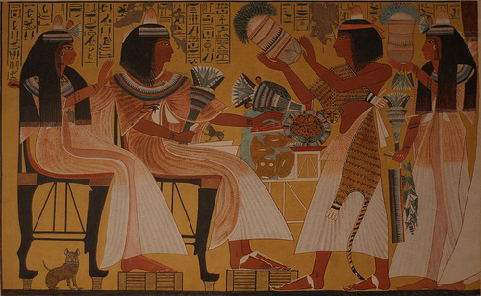  - You could pretend you’re an Ancient Egyptian and write a letter to people in the future explaining what your life was like.  - You could write a questions and answers lift and flap poster to record your findings.  - Draw yourself as an Ancient Egyptian (add labels and captions) and describe what job you would have had. You could draw your picture and then add your head from a photograph.  - Make your own Egyptian flatbread  The recipe is on the BBC bitesize website (bam.files.bbci.co.uk)  bbc.co.uk, bitesize, Ancient Egypt is a really accessible website.  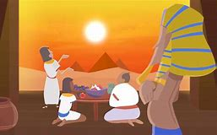
Other suggestions | The artist Rob Biddulph is a popular website that gives you online tutorials to draw characters in a cartoony style. If you haven’t already been using this website, you might enjoy this.  http://www.robbiddulph.com/draw-with-rob  VE day is on Friday the 8th May. This is when the country will commemorate the official end of the second world war. You may like to have a picnic lunch in your front or back garden (remember to stay at home and stay safe).  - You could help to plan and make the picnic  - bake some cakes or biscuits beforehand.  - Make some Union Jack flags  - Make bunting and decorations to hang or stick up.  - Dress in red, white and blue  Enjoy and remember to upload your pictures on Padlet.  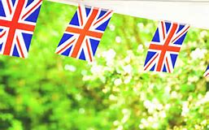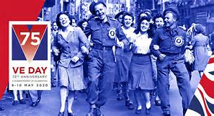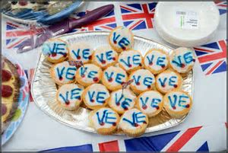  You may wish to find out more about VE day.  What is VE Day? - CBBC Newsround  https://www.bbc.co.uk/newsround/48201749  Perhaps you might like to draw a poster to advertise VE day
Enjoy your week with whatever activities you get up to.
Just remember to stay safe and stay at home.
Mrs Harvey and Mrs Handley X

