Year Three home based work
For the week beginning 27th April 2020
Please don’t feel like you have to do all of these, they are just suggestions.
I know it would have been the Easter holidays now but because you are all safely staying at home we thought we would still give you suggestions for activities to do to try to keep you busy.

deputy@sandiway.cheshire.sch.uk or khandley@sandiway.cheshire.sch.uk

Don’t forget to upload anything you are keen to share on our Padlet board. We may even add a few spontaneous challenges to our Padlet board too

Reading | Read at least three times and if possible daily. Paper books, Bug club and library books.  Read for pleasure as much as you can. This may be comics, recipes, instructions, books, jokes, newspapers, facts etc.  Try to add a book recommendation onto Padlet so that you can inspire others with what you have been reading.
Writing | There are a number of Egyptian themed writing opportunities listed in the Topic work section below.  This week, try to review what you know about adverbs. What do they do and when can you use them. Complete the sheet (Identifying Adverbs).  I will leave this up as an ongoing activity for you to keep having a look at:  Go back and review spellings covered since September and ensure you are still confident in spelling these words.  Additionally, return to the Y1 and 2 spelling list (a copy is on the Y3 page of the school website) and be really confident to spell these words accurately.
Maths | This week I have uploaded the multiplication and division practise booklet for you to work on. Like the addition and subtraction workbook,It is great revision of the work we have covered in class and builds up in the challenge as you got through it. It is certainly not to be completed in one sitting- it will take you a good few days at least.  When doing more complex division calculation, please use a numberline (this is as formal as we go in Y3 for division). You may wish to refer to the school’s calculation policy on the maths page of the school website.  A little more creative, how about this:  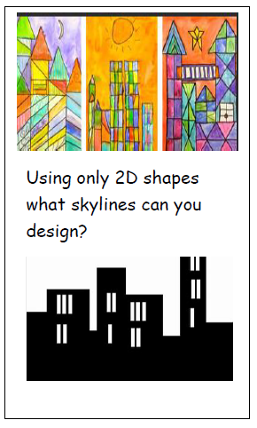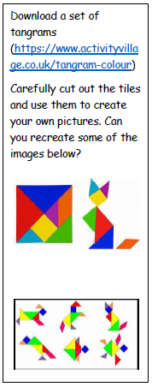  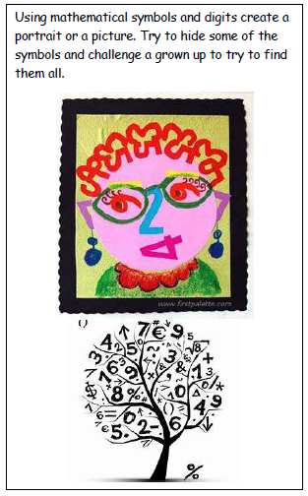  Returning to Lego:  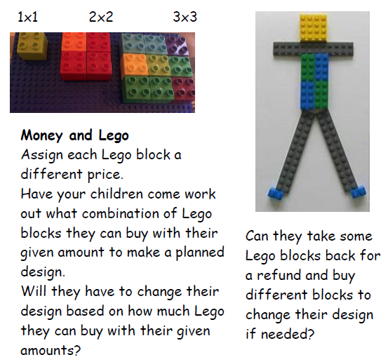  (Thanks to First4 maths for these ideas)  As always, keep up with times tables practise if you can.
Topic/ Creative work | Ancient Egyptians.  What can you find out about the boy king?  TUTANKHAMUN  - You could write a fact file,  - draw his death mask and then design your own Egyptian mask based on what you have found in your research.  - You could even make your own Egyptian mask.  - (Like Junior- see Padlet) you could have a go at making a small scale Sarcophagus (coffin).  - Write a description of the pharaoh or of his death mask  - When was his Tomb discovered?  - Find out about Howard Carter, the archaeologist who unearthed the pharaohs tomb.  - You could write a diary entry as though you had just uncovered King Tutankhamun’s tomb like Howard Carter did. How exciting that must have been for him and how he would want to tell the world about his discovery.  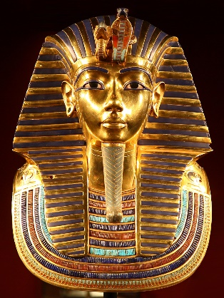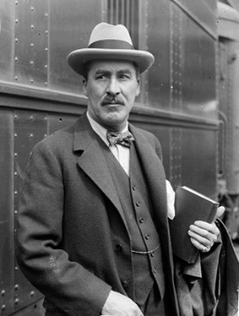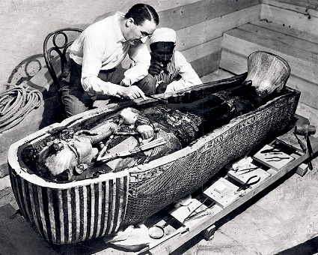
Other suggestions | Compose a piece of music- See Mrs Tucker’s attached file.  You may wish to upload a short video of yourself practising playing your musical instruments or singing a song (onto Padlet). It could be like a mini Sandiway’s Got Talent just for Year Three!
Enjoy your week with whatever activities you get up to.
Just remember to stay safe and stay at home.
Mrs Harvey and Mrs Handley
X

