Year Three home based work
For the week beginning 11th May 2020
Please don’t feel like you have to do all of these, they are just suggestions.
I know it would have been the Easter holidays now but because you are all safely staying at home we thought we would still give you suggestions for activities to do to try to keep you busy.

deputy@sandiway.cheshire.sch.uk or khandley@sandiway.cheshire.sch.uk

Don’t forget to upload anything you are keen to share on our Padlet board. We may even add a few spontaneous challenges to our Padlet board too

Reading | Read at least three times and if possible daily. Paper books, Bug club and library books.  Have a go at reading a variety of fairy tales, myths and legends this week and then have a go at retelling the story in your own words. Practise retelling it to yourself and then tell someone else the tale. Story telling is a really important skill. You could tell your version of your story to one of your grandparents over the phone or via facetime etc.  If you haven’t logged into bug club for a while, why don’t you have a go. I have checked and added additional books to those who have required them.
Writing | - As last week, there are a number of Egyptian themed writing opportunities listed in the Topic work section below.  - You could write a recount of your experience of the VE Day commemorations. You could plan your writing in paragraphs for each thing you may have done. You could include adverbs of time in your writing. The first, introductory paragraph could be an explanation of what the 75th anniversary of VE day is.  - Grammar and Punctuation Activity:  Using Speech in our writing  Upload the file named ‘Using Speech in our writing’ and remind yourself of the rules for using speech. Have a go at drawing your own comic strip and then writing this out in sentences afterwards.  I will leave this up as an ongoing activity for you to keep having a look at:  Go back and review spellings covered since September and ensure you are still confident in spelling these words.  Additionally, return to the Y1 and 2 spelling list (a copy is on the Y3 page of the school website) and be really confident to spell these words accurately.
Maths | Wherever possible, keep up with your times table practise of 2,3,4,5,8 and 10 times tables. How are you getting on with your mad minutes? Doing a few of these each week would be great practise. The templates are on the downloadable files on the Y3 class page  I have also added a blank mad minutes template for you to create your own sheets. You could add x and ÷ calculations and you may choose to do a sheet with more than one times table in it. Write the grid and come back a bit later to see how many you can answer in two minutes.  Additional ideas:  Creative maths to find all possibilities:  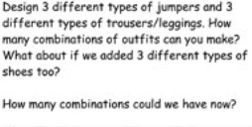  Some ideas for combining maths with your daily walk. Perk up your daily exercise!  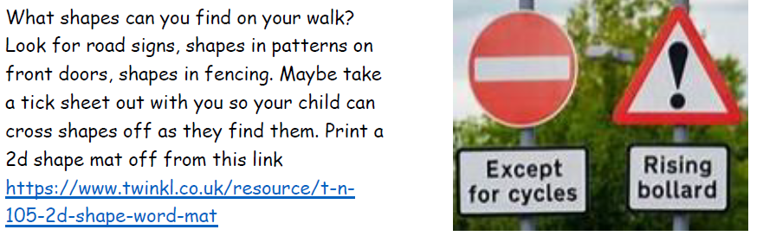  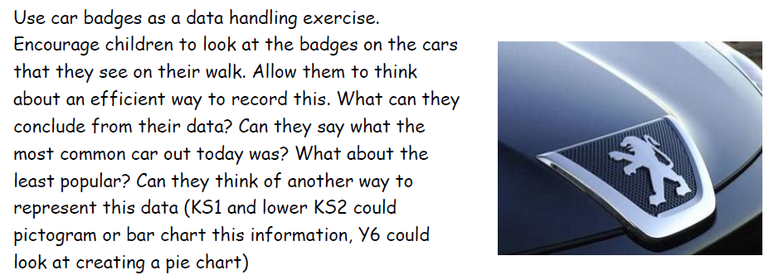  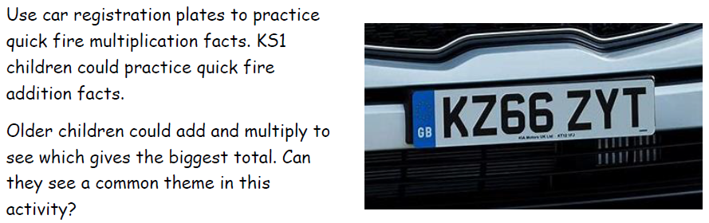  (Thanks to First4maths for these additional ideas)
Topic/ Creative work | Ancient Egyptians.  What did Ancient Egyptians believe in?  What did the Egyptians believe in?  Why were pyramids built?  Why were people mummified?  What is the process of mummification?  - You could write a set of instructions to tell people what the process of mummification is. Warning- it is rather gross!  - Draw some of the Egyptian gods and explain why they were important to the Ancient Egyptians.  - Write your own quiz about the Ancient Egyptian gods. Write the questions and then the answers at the end so other people will know the correct answer if they have a go at the quiz.  - Look at ancient Egyptian art with gods and pharaohs on them. Try to recreate your own Egyptian artwork. What materials, tools, techniques will you use?  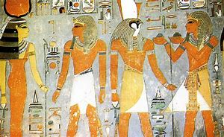  Computing:  Mrs Handley has set a number of 2dos on Purple Mash for you to recap on the Computing work you have been doing in class.  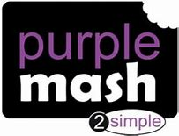
Other suggestions | Comic Strips  If you have used the Rob Biddulph website to learn how to draw some of his comic style characters, you could now have a go at putting the characters you have learnt to draw into a short comic strip.  http://www.robbiddulph.com/draw-with-rob  I would make a Sausage dog story as my comic strip based on Bob’s guidance. Superhero Sausage dog would rescue other sausage dogs that get themselves into sticky situations. E.g. He could rescue ‘Ketchup’ the Sausage Dog before he gets eaten as a hot dog!  Animation  You could have a go at a stop motion animation of some description. You could use small lego figures or make up/draw your own characters to tell a short story. Perhaps your stop motion animation could give people a message. For example, to thank the NHS, to tell people to recycle, an anti-bullying message or simply to have a go at making an object move etc. the choice is yours!  You can use the software on Purple Mash ‘2animate’ for this.  The following video also shows how to use the software:  https://vimeo.com/55086739  If you produce anything, please do share it on padlet.  Enjoy!
Enjoy your week with whatever activities you get up to.
Just remember to stay safe and stay at home.
Mrs Harvey and Mrs Handley X

