Can I use Speech punctuation accurately?
1.  This is my favourite book! | 2.  Do you want to play football with me? | 3.  Don’t talk to strangers! | 4.  I had a cheese sandwich for dinner.
Lucy exclaimed, “this is my favourite book”!
5.  I hope you are listening to my instructions. | 6.  I like playing in defence. | 7.  You need complete bed rest. | 8.
 |  |  | Santa told the elves, “Hurry up, or we’ll be late”!

Now have a go at writing your own short comic strip. It could be about anything. Here is an example of a Garfield comic strip.
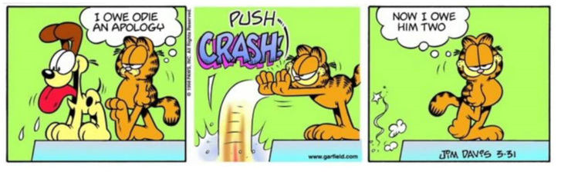

Now, have a go at writing out your comic strip in sentences, using the rules of writing speech.



