Year Two Home Based Learning
Week 8- Monday 10th May 2020
Welcome to Week 8,

I hope you have all had a lovely Bank Holiday weekend and enjoyed your VE Day activities.
Thank you to everyone who joined in with our Zoom meeting last Thursday, I hope you enjoyed drawing with Rob. It was lovely to see you all. There is no pressure to join in on Zoom, just popping in to say hi for a few minutes is great. We love it because Mrs Whitney and I get to see all your lovely smiling faces!

Keep posting on Padlet, it’s lovely to see what you have been doing! I have set up a new Padlet as it was so full of your lovely contributions that it was getting very slow. The new details are: https://padlet.com/satkinson16/ib0n0x30mhmlix2e
To post on it you need to click on the red circle with the white add sign.

Watch out for more ideas on here, I will post any interesting links or activities I come across.

I will hold another Zoom meeting on Thursday at 11am. In order to keep the login as secure as possible Mr Priddey will email it to you on Thursday morning so please look out for it!

Please continue to use the BBC Bitesize Website for alternative activities. You could have a go at anything on here that catches your eye.

BBC Bitesize
https://www.bbc.co.uk/bitesize/levels/z3g4d2p
Letters and Sounds Phonics
https://www.youtube.com/channel/UCP_FbjYUP_UtldV2K_-niWw/featured?disable_polymer=1

If you want to contact me I will be checking my emails satkinson@sandiway.cheshire.sch.uk and I will do my best to respond promptly.
Reading | Read daily. This is probably the most important thing you can do.  Can you complete a reading challenge (see website)?  It is great to see you have been accessing Bug Club. I am monitoring the use of Bug Club closely. This last week 26 children logged onto Bug Club and completed quizzes- well done all of you. Make sure you answer the questions fully; I love reading your answers. It would be great if we could get everyone using it. I will check who has been using it well and will give you a special mention in our Zoom meeting.  Watch Newsround and find out what is happening in the world. What did you find out? Is there anything you need help understanding?  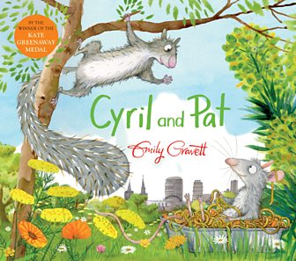  You will find this reading activity on BBC Bitesize. Have a go at answering the questions.
Phonics/spelling tasks | Login to our favourite phonics website: Phonics Play  www.phonicsplay.co.uk  username: march20  Password: home  You can revisit all the Phase 5 and 6 games that we have used in school.  Use the Activity Cards on Week 6’s Home Based Learning to practise your spellings.
Writing | Book favourites  Which books have you read this year? Which one was your favourite?  Write a retelling of the story. Think about who the characters were. What places did they visit? What happened in the story?  Write your version of the story.  Use story language – Once upon a time, One day, Suddenly  Remember to write lots of different sentences. Can you use and, but, because, when, so that?  Have a go at your writing and then re-read it. Can you improve it? Add more detail, add more adventurous vocabulary. You might need to re write your final piece in your best handwriting.
Maths | Below is a link to the White Rose Maths site. This site is also aligned to the BBC Bitesize lessons.  This week we are revisiting addition and subtraction. There are videos on BBC Bitesize and I’ve also added some work sheets for you to do on the Year 2 class page. If you do the column addition follow the video carefully as this is something we haven’t done in Year 2. The 1* is the easiest sheet and 3* are more challenging.  First 4 maths have also given us a sheet for practical maths activities.  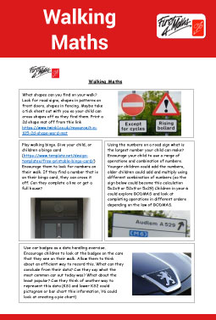  A PDF can be found on the Year 2 page.
Science | Choose a science investigation and have a go!  https://sciencebob.com/category/experiments/  NB These investigations will need adult supervision!
Computing | Coding  Logon to Purple Mash. I have set you some coding activities on your 2do. You could also watch the coding videos on Bitesize this week.
PE/exercise | Vale Royal School Sport Partnership have got some great sport challenges to get you moving. They have a challenge for everyday and have made cool videos to show you what to do.  https://valeroyalschoolsport.org/home-learning-archive/
Additional reosources/websites | Classroom Secrets Learning Packs - These packs are split into different year groups and include activities linked to reading, writing, maths and practical ideas you can do around the home.  Twinkl - to access these resources click on the link and sign up using your own email address and creating your own password. Use the offer code UKTWINKLHELPS.  The Scouts Lots of great activities  https://www.scouts.org.uk/the-great-indoors/

