Year Three home based work
For the week beginning 11th May 2020
Please don’t feel like you have to do all of these, they are just suggestions.
I know it would have been the Easter holidays now but because you are all safely staying at home we thought we would still give you suggestions for activities to do to try to keep you busy.

deputy@sandiway.cheshire.sch.uk or khandley@sandiway.cheshire.sch.uk

Our New Padlet Board
Don’t forget to upload anything you are keen to share on our Padlet board.
We have a new link for Padlet as we filled up the first one with all our lockdown adventures!
https://padlet.com/khandley4/zsf9mvmbn7hp93ld

Reading | Read at least three times and if possible daily. Paper books, Bug club and library books.  This week read some poetry. Consider a small collection of poems. What features do they have in them? (you may consider: rhythm, rhyme, alliteration, similes and metaphors, personification, onomatopoeia, imagery) How do the poems make you feel? What are the poems telling you about?  You could use the Mummy poem in the files below.  You may also like to use https://www.bbc.co.uk/bitesize/topics/z4mmn39 to help you  There are a selection of classic poems here too:  https://www.twinkl.co.uk/resource/t2-e-4790-ks2-classic-poetry-resource-pack  Learn a poem and try to recite it to someone in your family. If you are feeling brave you could record yourself performing your poem  And then upload it onto Padlet for other people in your class to enjoy.
Writing | Writing Ideas:  - Using what you know about Ancient Egypt, have a go at writing a story about discovering an Egyptian tomb.  What characters would you create?  What would the setting be like?  What will the plot be?  What could the problem be and how will it be resolved?  You could write a story plan first, then write your story carefully and finaly edit and improve it when you have completed it. Remember you could consider using some ambitious word choices, some adverbs of time, prepositions, paragraphs, speech and different sentence types.  - Have a go at writing your own poem. This could be a topic of your own choice but a few suggestions could be an Egyptian inspired poem, a poem about your pets, a poem about lockdown, a poem about your dreams and aspirations. Remember to upload anything you’re proud of on Padlet or email it to us.  - Grammar and Punctuation Activity:  This week have a look at the downloaded file ‘Different Sentence Types’. This is something we have worked on in both Y2 and Year 3 so once you have reviewed it, you should pick it up quite quickly.  - Spelling  After practising your spellings over the last few weeks, now ask you helper to give you a spelling test to see how you are getting on with your given word lists. Then, continue to practise any you are making mistakes with.  I will leave this up as an ongoing activity for you to keep having a look at:  Go back and review spellings covered since September and ensure you are still confident in spelling these words.  Additionally, return to the Y1 and 2 spelling list (a copy is on the Y3 page of the school website) and be really confident to spell these words accurately.
Maths | This week review money with the two sheets for you to download. One is finding the correct coins and the other will require you to apply your subtraction knowledge to find out if the change given is correct or not.  You could also do some practical money work- play shop etc.  Wherever possible, keep up with your times table practise of 2,3,4,5,8 and 10 times tables.  Additional ideas:  Continuing our Geometry work:  The Geometry sheets I set a couple of weeks ago can be found in the gallery should you wish to access them.  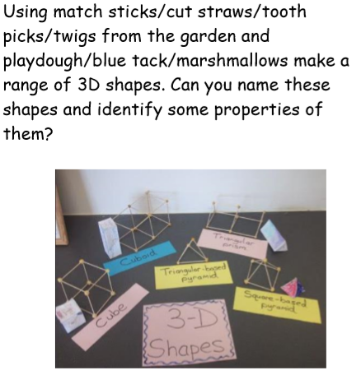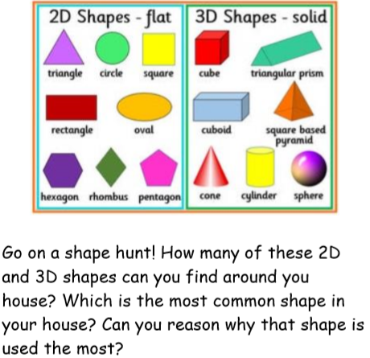  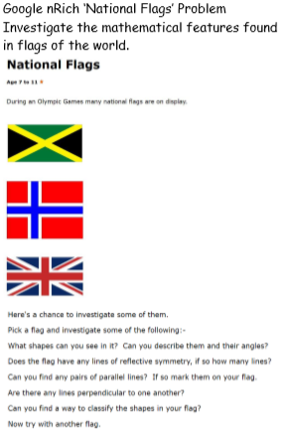  Have a go at revisiting estimation and time  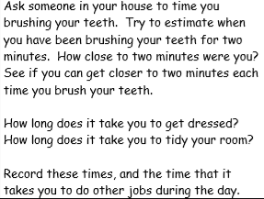  (Thanks to First4maths for these additional ideas)
Topic/ Creative work | Ancient Egyptians.  How do we know so much about Ancient Egyptians?  What is Egyptology?  What does an Egyptologist do?  What is the Rosetta Stone? Why is it important? Where can you find it?  https://www.bbc.co.uk/bitesize/topics/zg87xnb/articles/zr7qy9q/  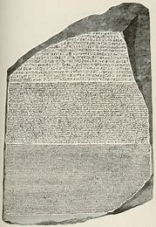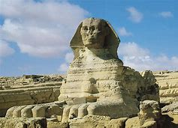  - Can you answer my questions?  - Draw a picture with yourself as an Egyptologist with lots of artefacts you might research.  - What would make you want to be and Egyptologist or not? Try to give reasons for and against.  Art/DT  Have a go at designing and making your own piece of Egyptian Jewellery or shoes. Look at Egyptian artefacts to get some ideas. You could try papier mache.  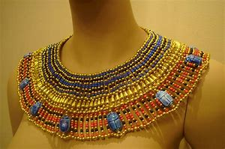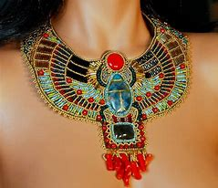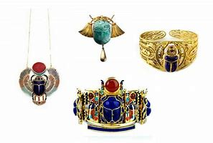  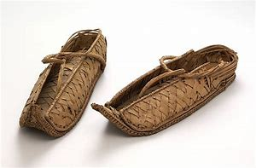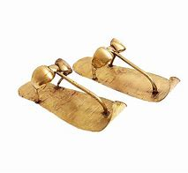  Science:  Mrs Handley is keen to encourage you to recap on the Science work you covered in class. For example, you could have a go at growing cress in different environments or try the food dye experience with white flowers.
Other ideas | The weather forecast this week is for warm weather.  Why don’t you go for a senses walk? Note down what you see, hear, smell and feel.  You could even consider how many of each thing you see/hear etc and collect and record your data in some way. How might you do this?  Paint something- preferably on a large scale  This could be painting a picture on the back of large sheets of wallpaper, painting with water on your patio and photographing it before it dries, helping your parents to paint a fence or the shed etc, you could paint smaller pictures, cut them out and put them onto one larger scale picture like a vase of flowers (think recreating a large version of Van Gogh’s sunflowers)  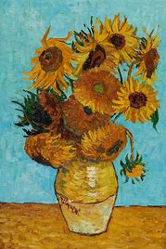
Enjoy your week with whatever activities you get up to.
Just remember to stay safe and stay at home as much as you can.
Mrs Harvey and Mrs Handley X

