Working together to Improve Attendance Policy

(September 2023)

Create Learning Trust



(written in line with the DFE’s ***Working Together to Improve Attendance*** August 2023)

Create Learning Trust recognises that the majority of children have ‘good’ attendance (96% or higher). School staff, leaders, governors and trustees along with our families work together to ensure that their children are happy to come into school.

School non-attendance or lower than expected attendance can impact negatively on children’s social and emotional development. There is a direct link between school non-attendance and lower than expected attainment. If a child isn’t in school, then they cannot learn with their peers.

Create Learning Trust’s schools aim to work closely with families where their child or children have low attendance or are a persistent absentee (90% or lower attendance)

* Senior Leader for the strategic approach to improving attendance; **Mrs Deborah Bertram (Head Teacher)**
* Member of staff with delegated responsibility for supporting families to improve attendance; **Mrs Margi Ireland (Family Support Worker)**
* Governor who oversees attendance strategy and policy; **Mrs Emma Zoubhi**
* Members of staff who receive absence calls and chases up any unknown absence; **Mrs Liz Segrott and Mrs Amy Sawicki**

The law on school attendance and right to a full-time education (***Working Together to Improve Attendance*** August 2023 Department for Education)

The law entitles every child of compulsory school age to an efficient, full-time education suitable to their age, aptitude, and any special educational need they may have**. It is the legal responsibility of every parent to make sure their child receives that education either by attendance at a school** or by education otherwise than at a school.

Where parents decide to have their child registered at school, they have an additional legal duty to ensure their child attends that school regularly. This means their child must attend every day that the school is open, except in a small number of allowable circumstances such as being too ill to attend or being given permission for an absence in advance from the school.

How will we support good attendance at Sandiway ?

At Sandiway we will aim to treat any root causes of absence and remove barriers to attendance, at home or in school. Our core values of Respect, Ownership, Caring and Kindness will ensure we work closely with families to support them when necessary.

At Sandiway, school staff will:

**MONITOR** Rigorously use our school’s attendance data to identify patterns of poor attendance as soon as possible so all parties can work together to resolve them before they become entrenched. *Mrs Ireland will access the school’s attendance data on a weekly basis to identify any patterns of low attendance and contact families if necessary.*

**EXPECT** Aspire to high standards of attendance from all children and parents and work within our positive culture where all can, and want to, be in school and ready to learn.

**LISTEN AND UNDERSTAND** When a pattern is spotted, discuss with children and parents to listen to understand barriers to attendance and agree how all partners can work together to resolve them.

**FACILITATE SUPPORT** Remove barriers in school and help children and parents to access the support they need to overcome the barriers outside of school *(this may include a support and attendance plan)*

**FORMALISE SUPPORT** Where absence persists and voluntary support is not working or not being engaged with, partners should work together to explain the consequences clearly and ensure support is also in place to enable families to respond. Depending on the circumstances this may include formalising support through a parenting contract or education supervision order.

**ENFORCE** Where all other avenues have been exhausted and support is not working or not being engaged with, enforce attendance through statutory intervention or prosecution to protect the pupil’s right to an education (see Appendix 2)

|  |  |  |  |  |
| --- | --- | --- | --- | --- |
| Attendance % over a school year | Equal to number of days absent | Converted to approximate weeks of absence | Weeks of learning lost over 7 years of primary school |  |
| 95% | 9.5 | 2 weeks | 14 weeks |  |
| 90% | 19 | 4 weeks | 28 weeks |  |
| 80% | 38 | 8 weeks | 1 year and 1 month |  |
| 70% | 57 | 12 weeks | 1 year and 8 months |  | |

Example of the number of days absence and what it equates to over time

At Sandiway, the start of the school day begins with the **doors opening to children at 8.45am**; the **register is taken at 8.55am;** the **register closes at 9.25am.**

Informing School about an unexpected absence

* Please **ring school as early as possible** (01606 883298) and leave a message on the absence line; **Name of the child, class they are in and reason for absence**
* If the child remains absent on day 3, then a member of the admin team will call a parent or carer to receive an update as to when it is hoped the child can return to school
* If the child remains absent on day 5 following an unexpected absence, then a member of the admin team will make a further welfare call and raise this absence with our family support worker (Margi Ireland)
* Our family support worker will contact the child’s family to offer any support (if needed) – a letter may be sent to families to outline support offered to parents

What happens if a child is late?

Arriving at school late can be quite distressing for a child especially as they have to walk into a full classroom having missed the start of teaching. We would like to stress the importance of arriving in school BEFORE 8.55am.

* Arriving at school after 8.55am is considered ‘Late’
* This will be recorded as ‘L’ on the child’s register
* The child with their parent will need to come to the main entrance to gain access to the school
* The parent will need to record the reason for lateness in the electronic ‘signing in’ system
* The school’s admin staff will inform our Family Support Worker of regular ‘lateness’

What happens if school is not informed of a child’s absence

* A member of the admin team will contact each of the child’s emergency contact numbers to determine why the child isn’t in school. This will take place by 9.30am
* If we cannot make any contact with a parent/carer, then a member of the admin team will email the parent/carer and the named contacts for your child asking them to contact school immediately.

Family Holidays in Term Time

* Create Learning Trust asks all parents to speak with the Head Teacher BEFORE booking a holiday in term time. A senior leader can then inform parents about the risks linked to taking a holiday in term time and how this will affect their child’s attendance and subsequent learning time lost
* A family holiday is not considered an exceptional circumstance for absence. It will be marked as an ‘unauthorised’ absence and a holiday fine may be issued

**\*For any planned absence (including a family holiday), please call the admin team to arrange a meeting with Mrs Ireland or Mrs Bertram.**

Appendix 1

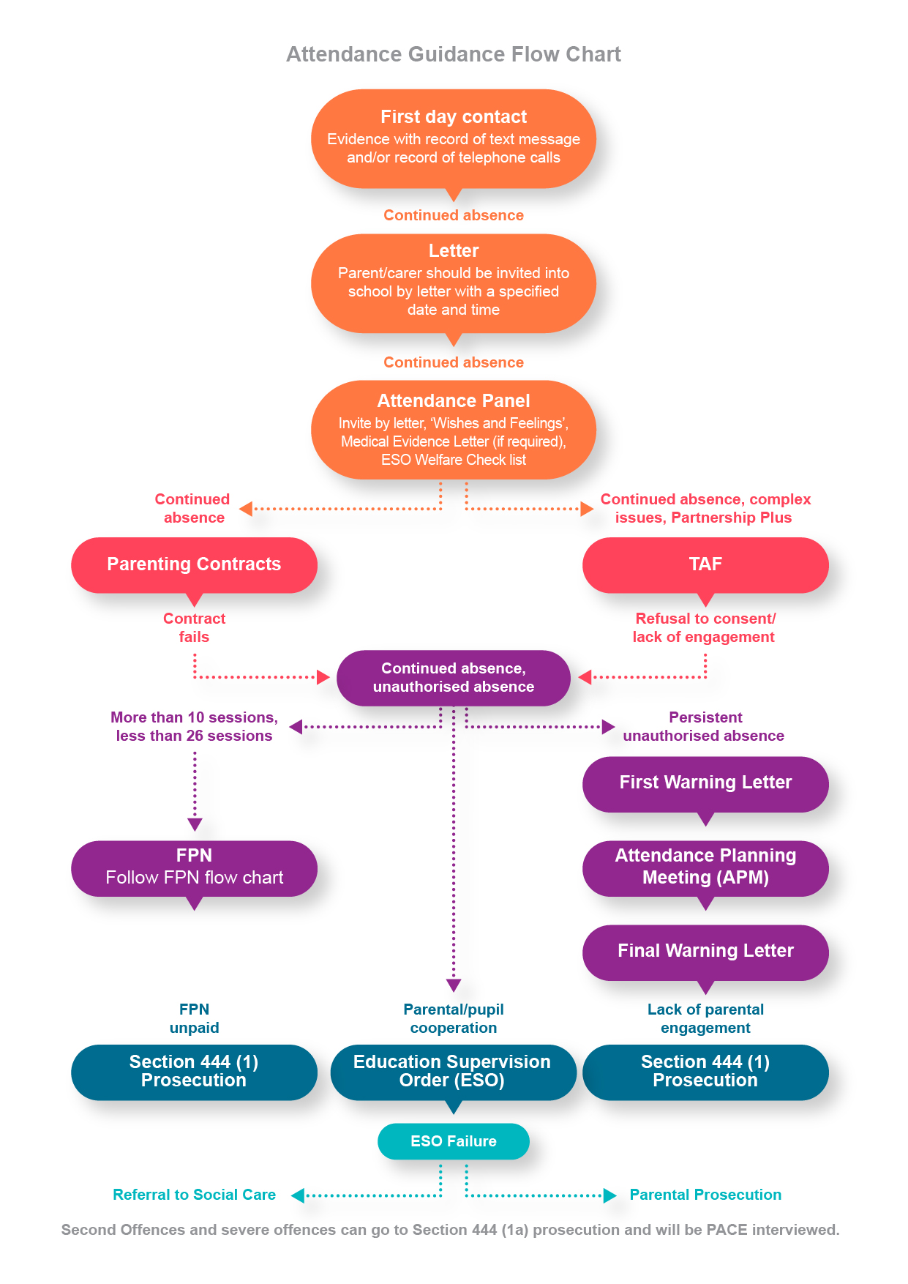

Appendix 2

