Sandiway Primary School

Parent Code of Conduct



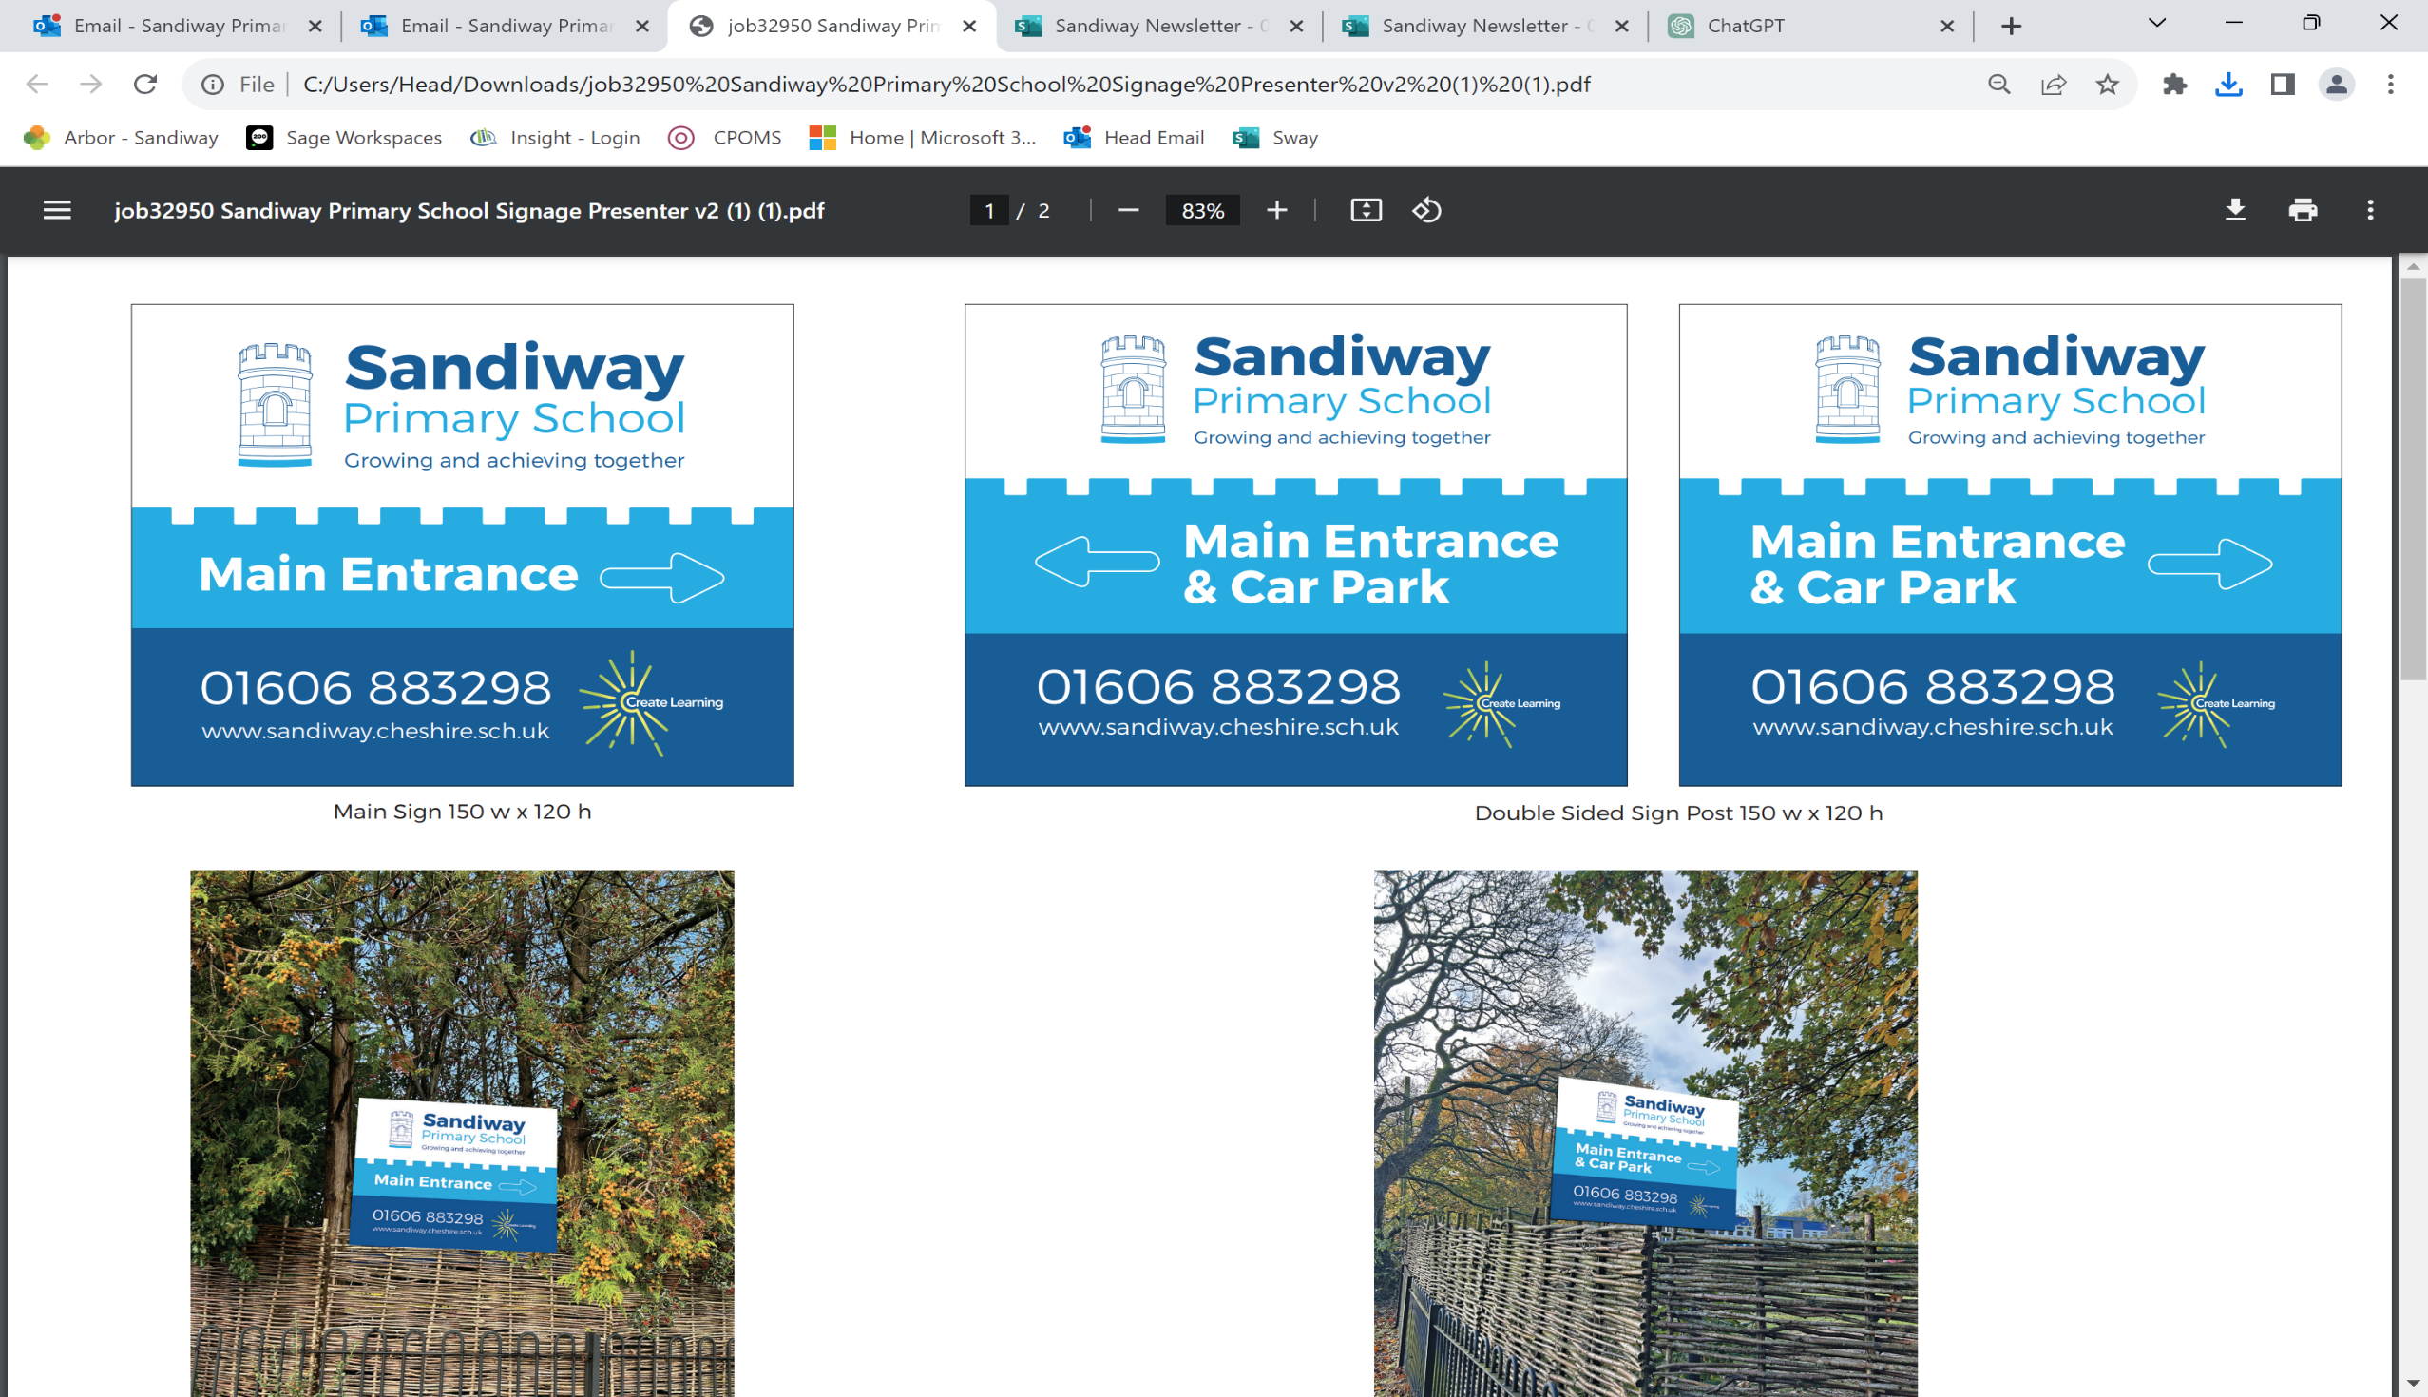

|  |  |  |
| --- | --- | --- |
| **Approved by:** | Governing Body | **Date:** March 2025 |
| **Last reviewed on:** | March 2025 |  |
| **Next review due by:** | March 2026 |  |

**Contents**

1. Purpose and scope 2
2. Our expectations of parents and carers 2
3. Behaviour that will not be tolerated 3
4. Breaching the code of conduct 3
5. Appendix 1 – Acceptable Use of Internet; agreement for Parents/ Carers 4

# Purpose and scope

We are very fortunate to have a supportive and friendly parent body. Our parents recognise that educating children is a process that involves partnership between parents, class teachers and the school community. As a partnership, our parents/carers will understand the importance of a good working relationship to equip children with the necessary skills for adulthood. For these reasons we continue to welcome and encourage parents/carers to participate fully in the life of our school.

At Sandiway Primary School, we believe it’s important to:

 Work in partnership with parents to support their child’s learning

 Create a safe, respectful and inclusive environment for pupils, staff and parents

 Model appropriate behaviour for our pupils at all times that reflects the values and ethos of the school

To help us do this, we set clear expectations and guidelines on behaviour for all members of our community. This includes staff (through the staff code of conduct) and pupils (through our Behaviour polices).

This code of conduct aims to help the school work together with parents/carers by setting guidelines on appropriate behaviour.

We use the term ‘parents’ to refer to:

 Anyone with parental responsibility for a pupil

 Anyone caring for a child (such as grandparents or child-minders)

# Our expectations of parents and carers

We expect parents, carers and other visitors to:

 Respect the ethos, vision and values of our school

 Work together with staff in the best interests of our pupils

 Treat all members of the school community with respect – setting a good example with speech and behaviour

 Seek a peaceful solution to all issues

 Correct their own child’s behaviour (or those in their care), particularly in public, where it could lead to conflict, aggression or unsafe conduct

 Approach the right member of school staff to help resolve any issues of concern

We expect parents to co-operate and show understanding and not to immediately challenge staff who have seen it fit to raise a concern or impose a sanction on their child. We are trying to do what is best for your child and whilst we do not enjoy making a child unhappy, it is sometimes necessary to sanction them. We are the adults in this relationship and so we ask that you do not immediately believe your child’s version of events.

After all, who has most at stake: a child that has got something wrong or the adult teacher simply pointing out and dealing with misbehaviour?

# Behaviour that will not be tolerated

 Disrupting, or threatening to disrupt, school operations (including events on the school grounds and sports team matches)

 Using loud or offensive language, swearing, or using profane language

 Displaying a temper, or shouting at members of staff, pupils or other parents

 Demanding meetings with staff and threatening to stay on site if this does not occur  Threatening another member of the school community

 Sending threatening or abusive messages to another member of the school community or the school, including via text, email or social media

 Posting defamatory, offensive or derogatory comments about the school, its staff or any member of its community, on social media platforms. Any concerns you may have about the school must be made through the appropriate channels by speaking to the class teacher, Headteacher or the Chair of Governors, so they can be dealt with fairly, appropriately and effectively for all concerned.

 Any aggressive or physical behaviour (including verbally or in writing) towards another child or adult

 Approaching someone else’s child in order to discuss or chastise them because of the actions of this child towards their own child. (Such an approach to a child may be seen to be an assault on that child and may have legal consequences). Please bring any behaviour incidents to a member of staff’s attention

 Smoking on the school premises

 Bringing dogs onto the school premises (other than guide dogs)

# Breaching the code of conduct

If the school suspects, or becomes aware, that a parent has breached the code of conduct, the school will gather information from those involved and speak to the parent about the incident.

Depending on the nature of the incident, the school may then:

 Send a warning letter to the parent

 Invite the parent into school to meet with a senior member of staff or the headteacher  Contact the appropriate authorities (in cases of criminal behaviour)

 Seek advice from our legal team regarding further action (in cases of conduct that may be libelous or slanderous)

 Ban the parent from the school site

The school will always respond to an incident in a proportional way. The final decision for how to respond to breaches of the code of conduct rests with the headteacher.

The headteacher will consult the Chair of Governors before banning a parent from the school site.

# Appendix 1

|  |
| --- |
| **Acceptable use of the internet: agreement for parents and carers** |
| Online channels are an important way for parents/carers to communicate with, or about, our school. The school uses the following channels:   * Seesaw and the school website * Email/text groups for parents (for school announcements and information) -schoolcomms * Arbor Communication System |
| When communicating with the school via official communication channels, or using private/independent channels to talk about the school, I will:   * Be respectful towards members of staff, and the school, at all times * Be respectful of other parents/carers and children * Direct any complaints or concerns through the school’s official channels, so they can be dealt with in line with the school’s complaints procedure   I will not:   * Use private groups or personal social media to complain about or criticise members of staff. This is not constructive and the school can’t improve or address issues unless they are raised in an appropriate way * Use private groups, or personal social media to complain about, or try to resolve, a behaviour issue involving other pupils. I will contact the school and speak to the appropriate member of staff if I’m aware of a specific behaviour issue or incident * Upload or share photos or videos on social media of any child other than my own, unless I have the permission of the other children’s parents/carers |